**To create and Attach volume**

**Step-1**

Go to instance Dashboard

**Step-2**

**Slide down left panel to find Elastic block store🡪 click on volume🡪click on create volume**

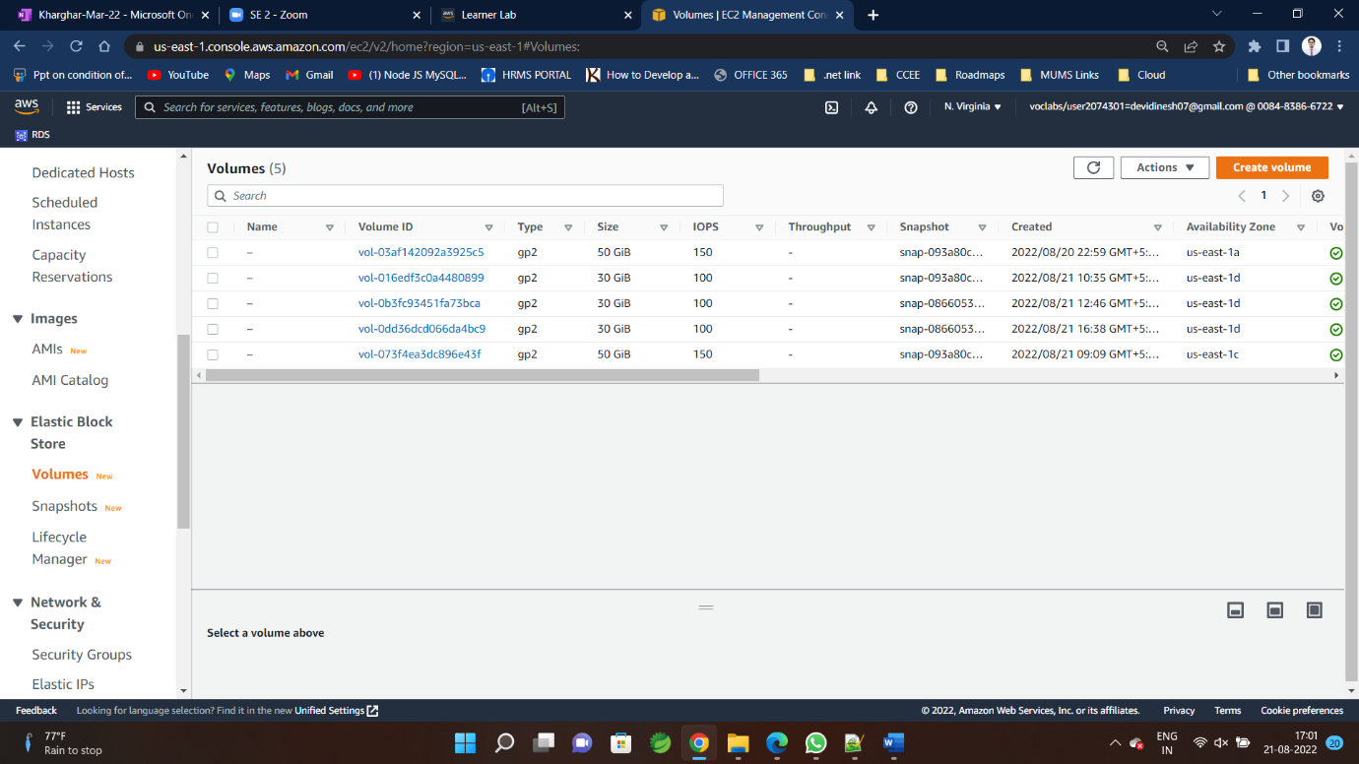

**Step-3 redirected to this window**

**Select Size and Availability zone as per EC2**

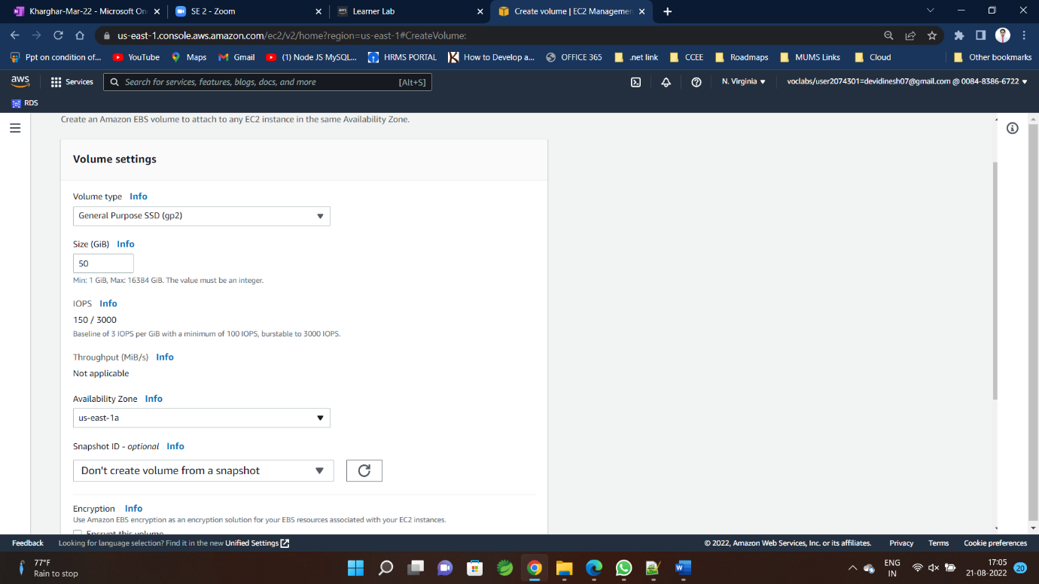

**Step-4**

**Click🡪 create Volume**

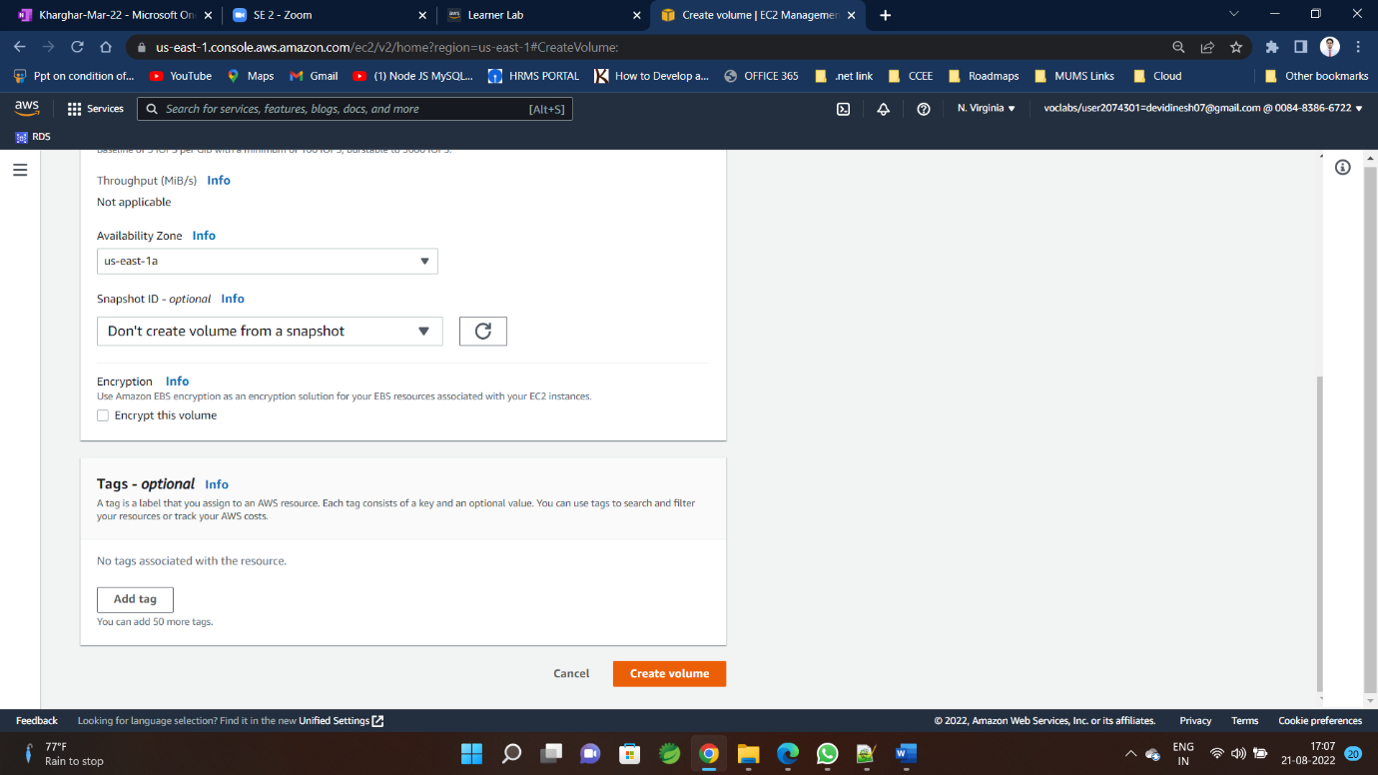

**Step-5**

**You can check availability zone of instance from here**

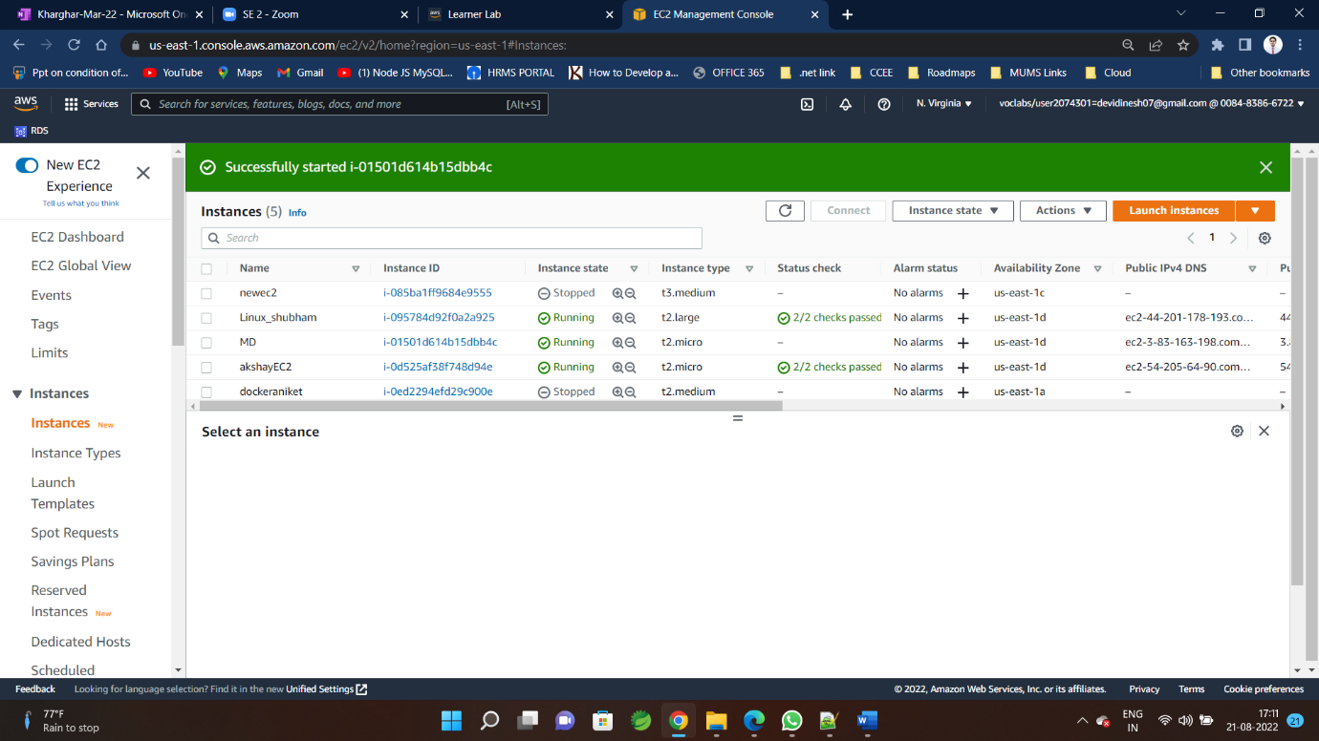

**Step-6**

**To Attach Volume To instance**

**Go to volumes🡪select volume🡪click 🡪action🡪 click Attach volume**

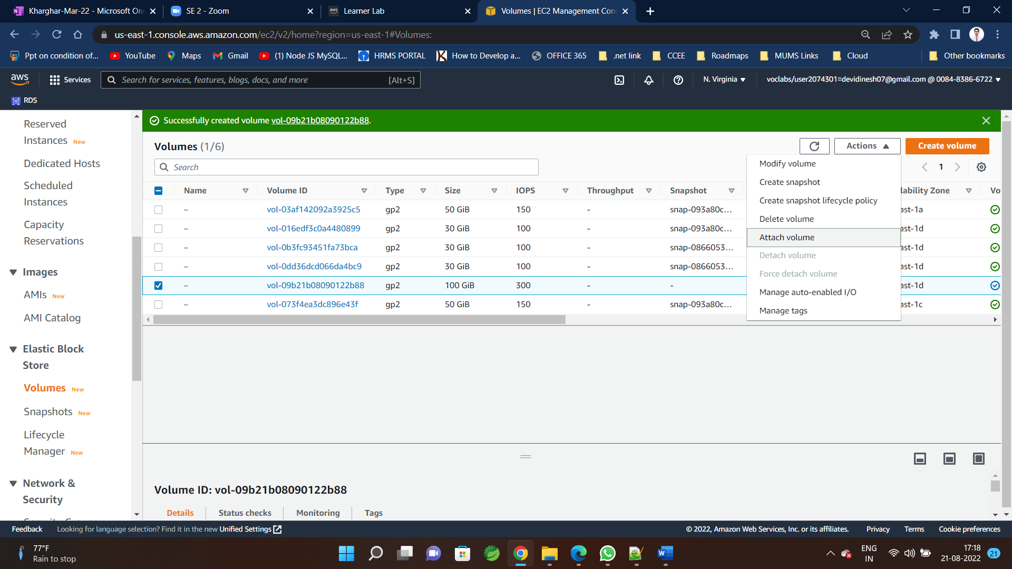

**Step-7**

**Select instance and 🡪 click attach volume**

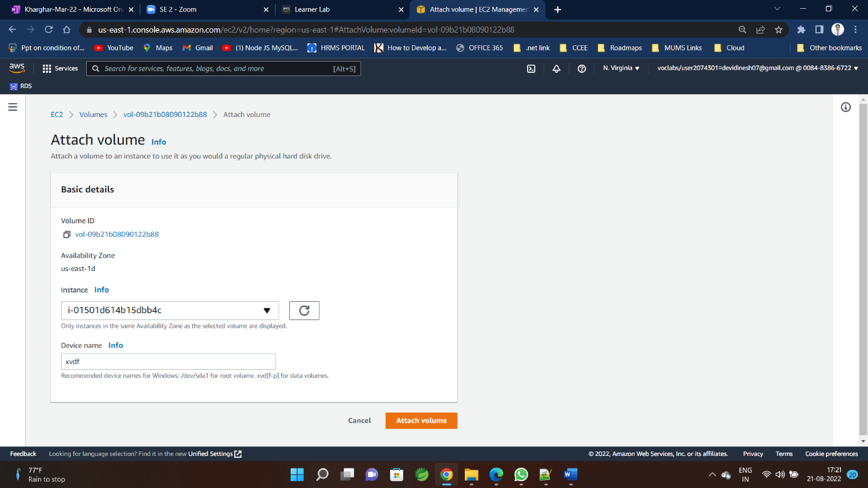

**Volume(100GB) attached with instance**

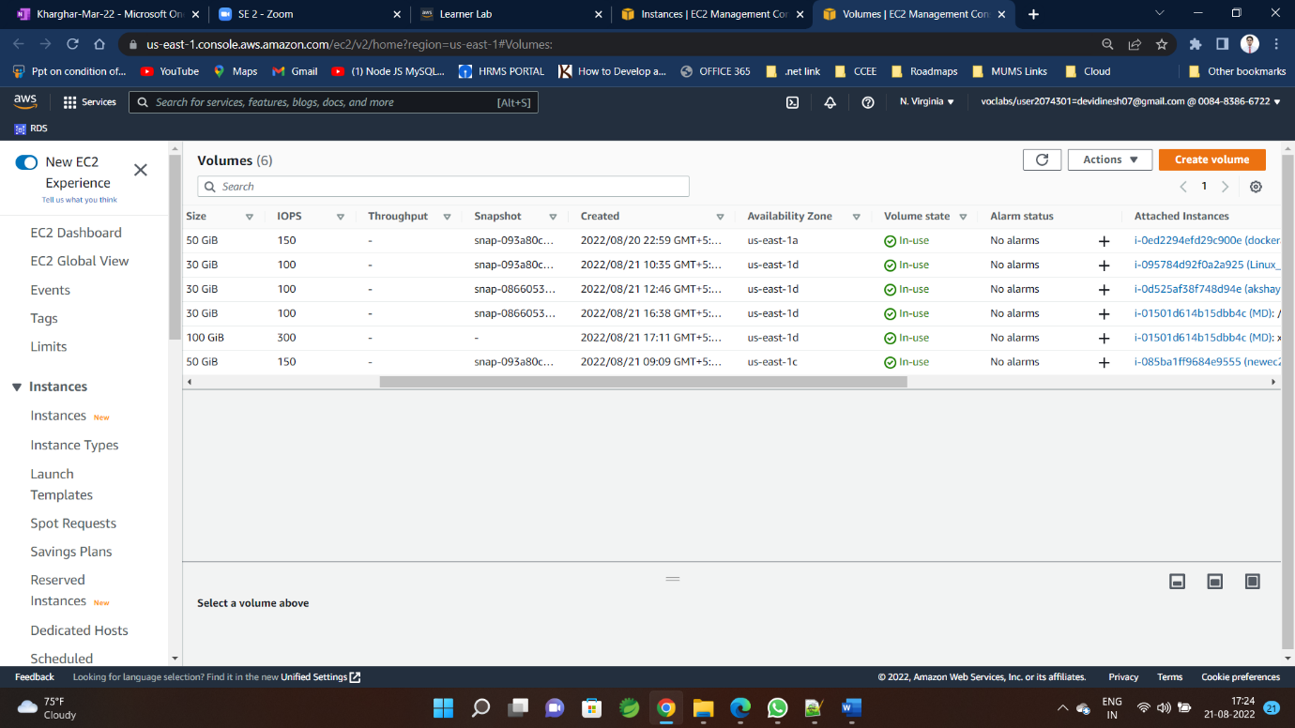

**Step-8**

**To check and use volume in EC2**

**Follow step to access EC2**

**Step-9**

**In EC2 type-create and format hard disk partion in search menu bar**

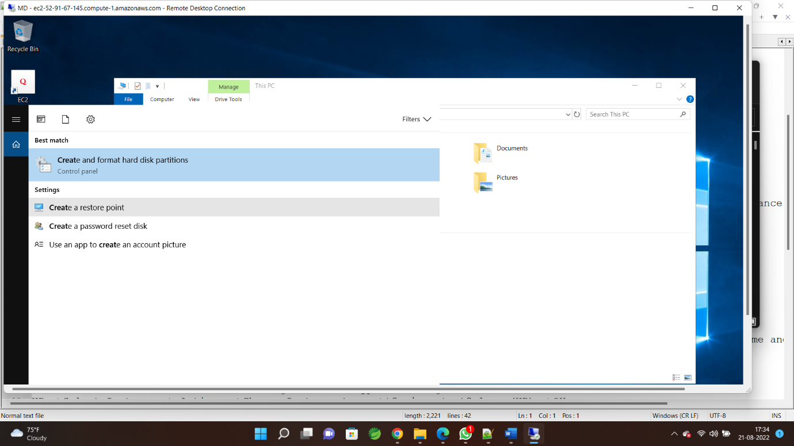

**Step-10**

**Disk management window open up**

**Right Click and make online**

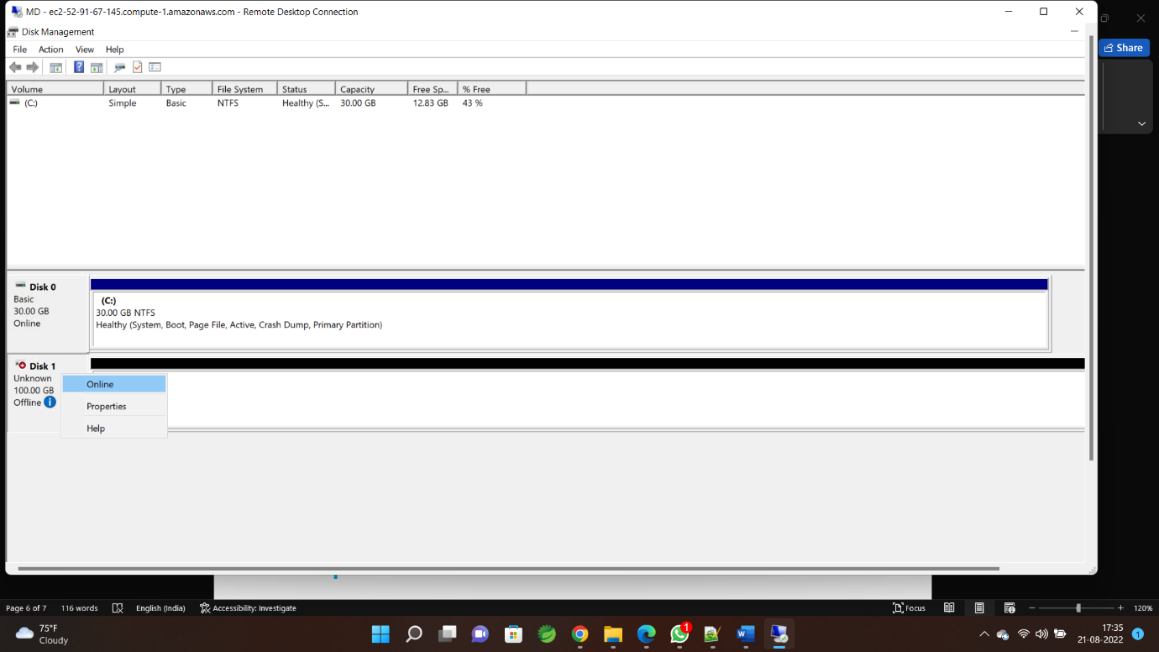

**Step-11**

**right Click🡪 click on Initialize Disk**

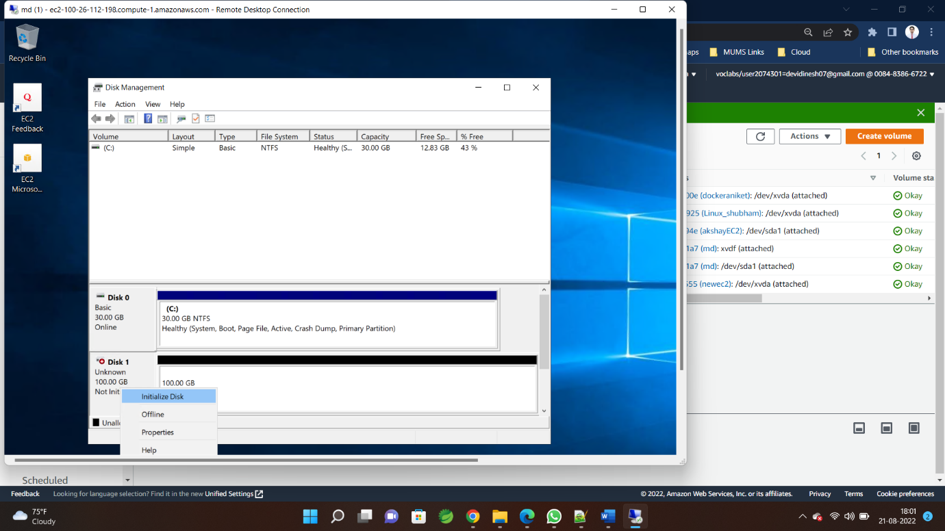

**Step-12**

**Right Click on disk space 🡪new Simple Volume**

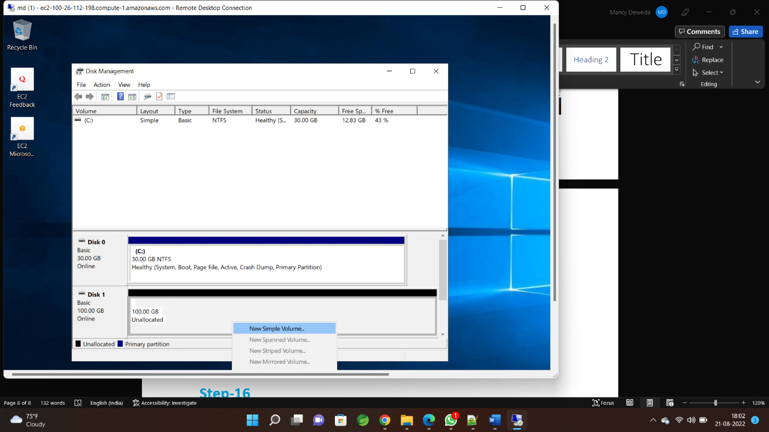

**Step-13**

**Configured new volume for use in EC**

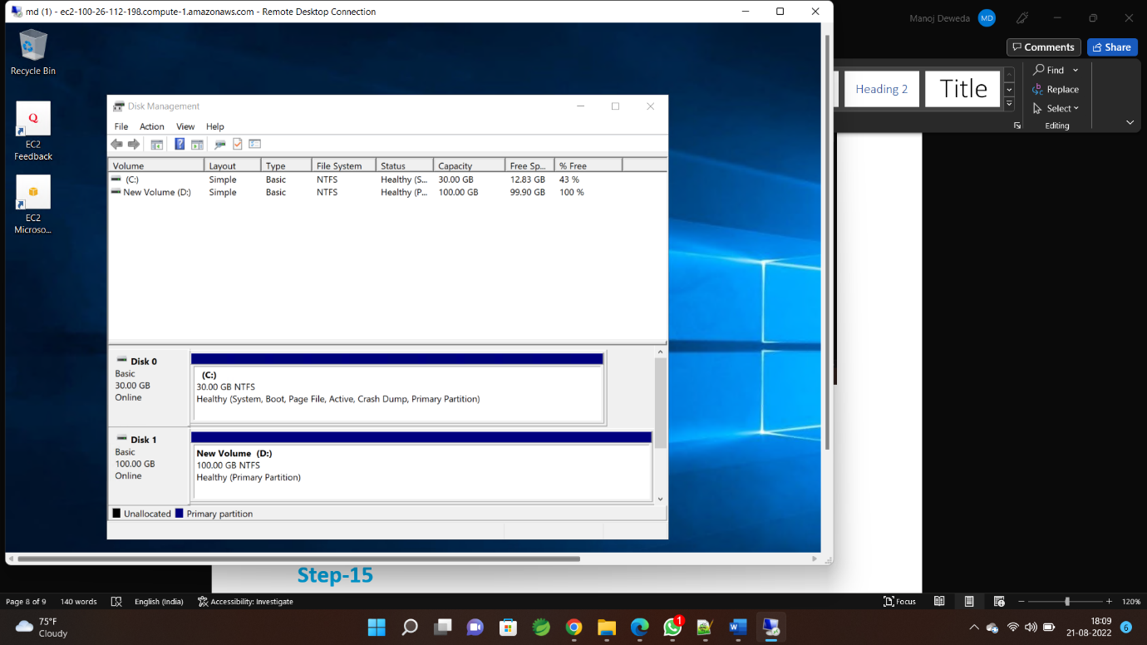

**Step-14**

**Now available here**

